Invitations to Learning Assignment
Karlee Andres
Opening Section
Grade: Grade 1
Main Outcome:
DS1.2 Inquire into the ways in which plants, animals, and humans adapt to daily and seasonal changes by changing their appearance, behaviour, and/or location. [CP, DM, SI] (Science)
I Can Statement:
I can talk about how plants, animals and humans change over time.
Essential Question:
How do plants, animals, and humans adapt to daily and seasonal changes by changing individual factors?
Indicator:
c. Examine daily changes in the characteristics, behaviours, and location of plants, animals, and humans (e.g., some animals sleep at night, students go to school during the day, and some plants close their leaves at night).
I can statement for indicator:
I can plant a seed and watch it grow.

Experience Description
Description:
In this experience students will learn about how plants grow and what plants need to grow healthy. The first each student will plant an individual sunflower seed to watch grow over a period of time. As a class, we will go over each element in order to plant a seed. Each day we will water the plants if they need. While the plant sprout and grow I will encourage the students to go investigate the plants and compare the plants each day. There are magnified glasses provided so they can get a closer look at the changes. I will plant a few extra plants to have some experiential seeds to examine. I will put some plants under the table, some in the box and the rest on the table. We will compare the locations of the plants and discover which plants grow best. As a class before the plants grow, we will come up with some questions and discuss what we think will happen to the plants in each location. Students are also welcome to read and look at the provided books about plants and seeds. There are seeds in the jars on the shelf that students will be encouraged to examine and compare the similarities and differences. The students will enjoy spending time in this area to discover changes about the seeds they planted. At the end of this invitational experience each student will be given a plant to take home and plant in their flowerbed or pot at home.

Materials:

- Sunflower Seeds to plant
- Pots
- Table
- Watering can
- Soils
- Water
- Bookshelf
- Windows
- Books
- Rug
- Recycled box that can close
- Magnifying glasses
- Jars
- Chalkboard
- Bulletin board
- Sunflower poster
- Big piece of paper
- Floor Cushions
- Variety of seeds
- Window

Additional outcomes/indicators:
Grade 1: Science
LT1.2: Analyze different ways in which plants, animals, and humans interact with various natural and constructed environments to meet their basic needs.
a. Identify the physical needs, (i.e., food, water, air, and shelter) that plants, animals, and humans require for survival.
b. Pose questions about ways in which plants interact with their environments to meet their basic needs (e.g., How long does it take a seed to start to grow? How does the growth of a plant change if the seed is planted in soil, sand, or rocks? How tall will a bean plant grow?).
DS1.2: Inquire into the ways in which plants, animals, and humans adapt to daily and seasonal changes by changing their appearance, behaviour, and/or location. [CP, DM, SI]
h. Pose new questions based on what was learned about plant, animal, and human adaptations to daily and seasonal changes.
Grade 1: Math
SS1.2: Sort 3-D objects and 2-D shapes using one attribute, and explain the sorting rule.
a) Sort a set of familiar 3-D objects or 2-D shapes using a given sorting rule.
b) Sort a set of familiar 3-D objects using a single attribute determined by the student and explain how the objects were sorted.
Grade 1: Art
CP1.8 Create art works that express own ideas and explore different forms (e.g., painting, drawing, printmaking) and media (paint, found objects).
- Identify and explore many different colours in own surroundings and in art works, and identify red, yellow, and blue as primary colours.
e. Recognize that what is seen of an object changes with different points of view
f. Describe own sources of ideas for art works, and discuss ideas in the art works of others such as picture book illustrations.

Space and Time Considerations:
This experience is placed near the window so the plants have sunlight. The plants are placed on a table, so they do not get bumped over. A couple plants will also be placed under the table and in the box for comparing the differences in the plants when placed in difference locations. There is a book cabinet with other experience materials in it available to the students. There is a rug and cushions on the floor for students to sit and enjoy the books about plants and seeds. They There are many plants in this area to make it feel like nature and lively. The plants will give a refreshing and calm fell to the classroom environment. Students will be encouraged to spend time in this area when they have free time or before class starts in the morning. The books could be read quietly when students have silent reading or have finished their work. Each day as a class we will have a small discussion about the change in the plants, so that all students understand the changes and know what to look for in the pots. The magnified glasses are placed on a low shelf at the bottom of the cabinet for each access when the students want to look at the plants sprout and change. The jars of seeds are set out for the students to compare and examine. Students could also do a sorting activity with the seeds in this invitation. This invitation will take a month to complete. It will take a couple weeks for the sunflower seeds to sprout and then we will continue to watch them grow for a few more weeks. Once we are done examining, the plants the students will each take one home to plant and will continue to be a learning experience.

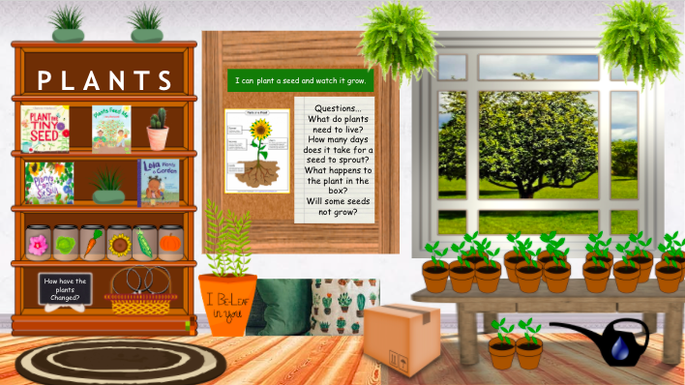
Image of the invitation:
Instructions or Prompts for Teacher or Students:
It is important to water the plants so they stay alive and there is something to observe. To keep this experience regulated, 2 or 3 students would be allowed to examine the plants at a time, so plants to not get bumped or dumped. Students should just observe with their eyes once they are set in the location, so nothing gets damaged or changed unnaturally. The “I can” statement is on the bulletin board for a reminder of our indicator. The questions are also posted up so the children can look back on the questions they came up with.
Book Resources:
Plants can’t sit still by Rebecca E. Hirsch
https://www.youtube.com/watch?v=NFHSSq7cmy4
- This book is about how plants are always moving. The seeds sprout and the plants will stretch to the sun. The variety of plants in this book shows the different ways plants grow and spread their seeds.
Plant the Tiny Seed by Christie Matheson
https://www.youtube.com/watch?v=JYMgUvqs-D4
- This book is about the growth stages of plants a seed and watching it grow. Throughout the book, it shows the plant needs water, sun, and dirt to grow. The pictures are also very informational for children who are not able to read yet.
Lola Plants a Garden by Anna Mcquinn
https://www.youtube.com/watch?v=OC7qurRN37A
- This book is about planting a garden and the things she does while Lola waiting for it to grow. Lola picked out seeds to plant, then bought the seed, planted them and waited for them to sprout. She made things to decorate her garden, and her friends can over to admire her garden once the flowers grew.
Plants Feed Me by Lizzy Rockwell
https://www.youtube.com/watch?v=SNs8Zl_Km14
- This book explains how some plants grow down and some plant grow up. It explains how different kinds of fruits, vegetables, grains, and nuts grow before we eat it. This book also explains which part of the plant we are eating when we eat the foods.
Web Resources:
How to Plant Seeds for an Easy Kids Gardening Activity
https://teaching2and3yearolds.com/how-to-plant-seeds-for-an-easy-kids-gardening-activity/#:~:text=I%20like%20to%20plant%20a,them%20in%20like%20a%20blanket.
- This website gives a great step by step explanation of how to plant a plant. The students are able to do this activity and will feel so proud of themselves in the end.
Parts of a Plant Poster
https://www.superteacherworksheets.com/featured-items/pz-parts-of-a-plant-poster.html
- This is a great poster with basic information on it. It will help the students identify the parts of a plant. They will be able to use these words in their vocabular when talking about their plants growing in the classroom.
Seeds in a Jar
https://www.pinterest.ca/pin/1548181109040988/sent/?invite_code=b7fab12eed1e432294aa7e71b5475998&sender=410601828435145172&sfo=1
- This is a great activity for students to examine and compare different kinds of seeds. I added this into my invitation. I think this is a great visual representation for the students to explore.
Bean Time- Lapse – 25 days
https://www.youtube.com/watch?v=w77zPAtVTuI
- This video shows how a plant grows over a period of 25 day. I think this is a great way to show the daily change in a plant growing because it may be hard to see the changes with your own eyes. This plant is always moving which you wouldn’t think from just looking at it.
Field Trip:
Langenburg Greenhouse
(306) 496-8808
It would be a fantastic learning experience to take the students to a greenhouse to explore many different kinds of plants. There would be a variety of different looking plants that the students could examine. The owner of the green house could also answer any question that the students have about plants and sees. Touring a greenhouse would give the students a better understanding of the daily changes or plants and seeds. This field trip could be done before planting the seeds, so children understand what they will look like when the plants grow.

