Classroom Planning Assignment
Karlee Andres
Grade: Grade 1 Classroom
Philosophy of Experiential Learning:
Experiential learning is a substantial way for students to explore and learn in a non-traditional teacher facilitating way because in experiential learning the students are the facilitators (Massing, 2021a). Traditionally the teacher would stand at the front of the room and the students would do the tasks and answer the questions the teacher is asking, but this is very hard to assess how many students are engaging because the teacher is doing all the work and the students are just sitting there (Davidson Films, 1996). I believe hands on learning is an important and effective way for students to learn and one way to incorporate this is through experiential learning. Experiential learning can be incorporated into a variety of subjects and curriculum topics (Massing, 2021a). One challenge with student directed learning is the students pick activities that are too easy or too difficult for the individual, so they do not comprehend the learning out of the activity (Davidson Films, 1996). This can be solved by one on one time or small group work with the teacher (Davidson Films, 1996). Extending the learning beyond the classroom is a fantastic why for students to understand the world around them. Going out in the community to visit local facilities such as the fire station, police station, or post office could be a great experience for the students (Massing, 2021a). Visiting small business in the community such as a hair salon, flower shop, restaurant, or greenhouse would also be great learning opportunities (Massing, 2021a). It would be even more powerful for the students learning to incorporate these community visits into the classroom with dramatic play areas, books and other resources (Massing, 2021a). I think when students are able to learn outside the classroom and then relate it into the classroom and home experience the learning is so much stronger. Personally, I remember most field trips outside of the classroom because the experience was fun and different from a regular day at school. In the experiential learning areas, a focus book may be placed with the materials as a base and summery of the learning experience (Massing, 2021a). There are books for all kinds of lessons and subjects that relate to curriculum content. Questions to prompt the children in student facilitated learning areas are beneficial so they know what they are encouraged to do with the materials at the station (Massing, 2021a). I think asking questions is a great way to direct the students without telling them what to do with the materials. Experiential learning allows students to be creative and use their imagination.

The Overall Classroom Atmosphere:
The classroom environment has a huge impact on the students in the classroom (Malaguzzi, 1994). In my dream classroom, it will be a welcoming environment for everyone who enters it. A classroom environment should be a positive aspect of a child’s life. It will be a happy place where students will enjoy spending time. The Reggio approach is a great way to add calm energy and a home like feel to a classroom (Massing, 2021b). The Reggio approach in a classroom includes aspects of a home into the school and classroom atmosphere, such as vases of flowers, or plants and avoids cartoon like images (Tarr, 2001). This classroom has wooden tables and natural aspects incorporated. In this classroom it conveys a cozy, calm feel that relaxes to students. To make this environment cozy there are multiple plants which will give it a fresh and lively feel. I have added area rugs to soften up the room and make the room feel like a home. In my classroom, design the colors very neutral toned, and add a small amount of color with soft pastels. Bright colors can be over whelming to the student (Massing, 2021b). When a classroom has too much going on and lots of color it can be a sensory overload for children, and may affect some of the children’s learning ability (Massing, 2021c). On the bulletin boards and walls there are inspirational quotes to inspire my student. All of the posters are neutral and not vibrant colors. Windows in a classroom provide natural light to brighten the classroom and allow students to see the outdoor environment (Massing, 2021b). Without windows the classroom would be a depressing atmosphere. In this classroom environment the lighting is bright from the 3 large windows allowing the sunlight to enter on the one side of the classroom. Most of the areas in the classroom are for student directed activities. Student materials should be placed at a low level for easy access for students to utilize (Massing, 2021b). In this classroom, the areas are welcoming to students and materials are accessible because of the open shelving filled with resources. The experiences will be adapted throughout the school year for the student to explore and learn new things. Students will eventually become bored with the resources provided so the student directed areas will have to be freshened up with new materials. When there is a classroom theme incorporated into the classroom all the areas could incorporate aspects of that particular theme. For example, a classroom could have themes such as winter, fall, water, space, plants, animals, and so much more. There are many different learning experiences that could be incorporated into a classroom. I want the energy of my classroom to be calming but fun at the same time. A calming environment makes it easier for student to focus. Every aspect in a classroom has an effect on the energy in the room (Massing, 2021b). It is very important for students to interact with each other during their school experience, and it is beneficial for their learning experience (Massing, 2021b). I feel that there are many opportunities for students to interact with each other in this classroom. There are areas for class discussion, partner work, small groups and the teacher, and an individual quiet time area. Incorporating different kinds of flexible setting for students such as the beanbag chairs, pillows on the floor, comfy chairs to read, wobble stools, yoga balls and regular chairs can benefit students learning (Massing, 2021c). If there was a student that needed a resource I didn’t already have I would incorporate and make it available to them. Overall, I think this classroom has a pleasant and tranquil feel that students will enjoy and excel in learning.
______________________________________________________________________________
Floor Plan:
Mostly everything is labelled on the diagram. The unlabelled shapes are to follow in the Key.
Key:
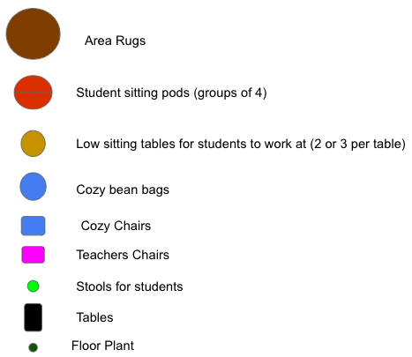
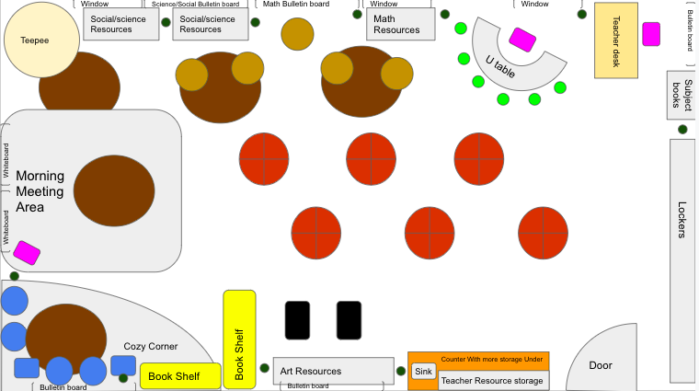
______________________________________________________________________________
Locker Area:
There will an assigned locker for each individual student. The lockers are where the students will keep their backpacks, lunch kits, and there outside clothes. In the top part of their lockers is where the students will keep a small basket containing their pencil, eraser, coloring materials, scissors, and glue. The baskets will have no holes in them to keep all there belonging contained. The containers will make it easy for students to find what they need and uncomplicated to put things away. On the front of the student’s locker they will be able to make name tags to emphasize their unique personalities. They could also make different names tags throughout the year to go with the themes in the classroom.
______________________________________________________________________________
Teacher’s Desk Area:
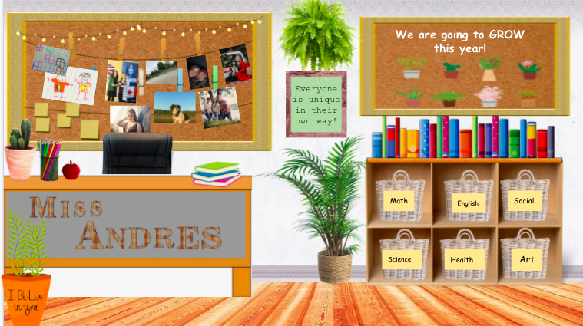
In my dream classroom, this is my desk area. This area will be welcoming to students to come visit or talk to me, but would also be private. In this area I will plan lessons and mark assignments. I would consider this my home base for all of my belongings and resources. In this area I think it is important to incorporate a touch of my personal life such as picture so my students know and can relate to my interests and family. As an elementary teacher, students make drawings and cards for their teacher and I think it is so cute important to display them, so they know I enjoy them. Displaying them at my desk area makes the area feel welcoming to the students as well. I have the student’s portfolios near my desk for easy access when marking or looking for a student’s work. The inspirational quote and cute bulletin board also make the area feel relaxing. On this bulletin board I will change in up to coordinate with the current season or theme that we are learning in class. The plants in this area make it feel fresh and lively. I need to enjoy spending time in this area because of all the time I will be spending there before and after school hours.
______________________________________________________________________________
U Table Area:
In this area it would be very clean and basic. This area could be used for activities in any subject area. The U table would be used for small groups or one on one interaction with the teacher. For the most part this area would be used for teacher facilitated learning. I would use this area to help students who don’t understand the content discussed in class get a better grasp on it. I would also use this area for guided reading stations with the teacher. This is a great place to really connect with the students and make sure they are on the right track.
______________________________________________________________________________
Morning Meeting Area:
In this area the teacher would be the facilitator. Morning meeting is where students sit in an area together and discuss the schedule for the day, things that are happening, and share stories and feelings (Massing, 2021a). What used to be called circle time is now recognized as a morning meeting (Massing, 2021a). My morning meeting area is at the front of the room. In this area the most important part is the rug on the floor because it makes this area feel soft and is more enjoyable for students to sit on the floor. In this area the colors will be light tones and not bright to make it calming. The inspirational quotes on the wall above the boards are a great reminder for students throughout the day. Specifically, in this particular morning meeting area we will discuss the date, weather, our words for the week, talk about our daily question, and read a story. I have related the question that the students will write about to the book that we will read as a class. This area could also be used for guest speakers, group work and teacher facilitated lessons or explanations. I think a meeting area like this makes the classroom feel like home and brings the entire class together as a whole. I think the stories and discussion that the students have in this area is important for learning and social interactions.
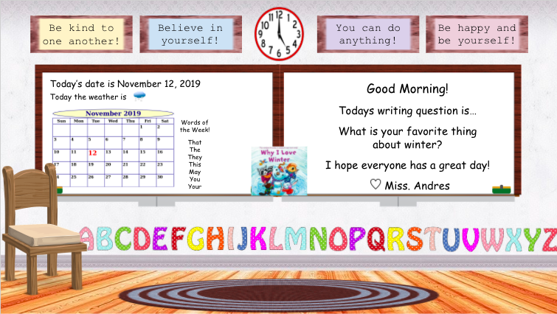

______________________________________________________________________________
Math Area:
In this area students can interact with manipulatives to explore math related topics such as counting, patterns, and measuring. In this area, I have provided students with manipulatives to count or measure things around the classroom. Commercial materials are open ended recourses that allow student to explore in their own way (Massing, 2021d). In the math area the materials a basic and very versatile. Materials such as counting bears, shapes, rulers, 10 frames, and dice can all used in this area. There will be opportunities to add many other math manipulatives to this area. I have provided some activates that students could do individually or in partners that are educational. Technology is incorporated into classrooms because it can be an interactive student resource. I would add materials or books when we were focusing on specific topics in class. The low tables in this area allow and welcome students to work with others. These tables would be for a maximum 3 people so they aren’t crowded. The guiding questions will help the students direct their learning. In this area we will also count the days of school up to day 100. The plants in this area make it feel lively and its educational to watch them grow at the same time.
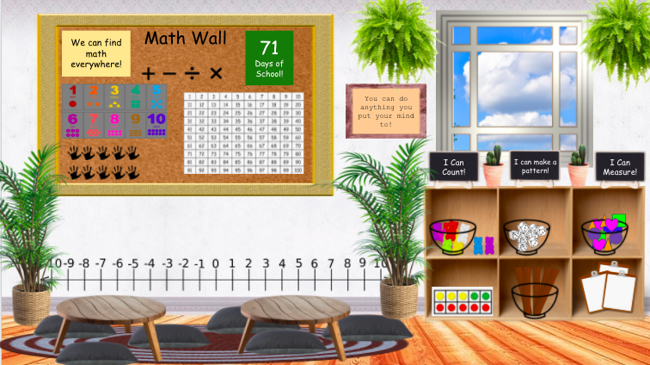

Math activities and images used:
Flash cards- https://www.dansmagazine.com/
Number chart- https://www.pinterest.ca/pin/313633561551388195/
10 frame- https://www.didax.com/apps/ten-frame/
Bear counting activity- https://toytheater.com/bear-counters/
______________________________________________________________________________
Social and Science Area:
In the social and science experiential learning area students would facilitate their learning. In this area there are low tables for students to sit at. The vibe in this area is soothing and natural. Students get a sense of nature when exploring in this area. The plants in this area make it feel like the outdoors and fresh. In this area there are many different kinds of materials being used. Commercial materials are open ended recourses that allow student to explore in their own way (Massing, 2021d). There are commercial materials in this area such as toy animals and building blocks. There are natural materials being used in this area, such as sticks, rock, pinecones, and plants. Natural materials give students connections to nature inside of the classroom and can facilitate learning with the objects (Massing, 2021d). In this learning area, there are plastic bottles that were recycled and turned into sensory bottles. There are many recycled materials that could be turned into useful materials, and can be done to save money (Massing, 2021d). Sensory materials refer to homemade materials for exploration (Massing, 2021d). In this area I have a scrapbook made with pictures of the student’s families because I think it is important to incorporate a student’s home life into the classroom. Families, culture and traditions could be shared in this book as well because it is a great way to incorporate and accept all kinds of cultural diversity. Cultural diversity should be shared in a classroom so everyone feels welcomed (Massing, 2021g). When a child is home sick they are welcome to go over and look at the picture of their family to comfort themselves. I think bringing these pictures in is also a great start to introducing family dynamics. The teepee would be an example of seclusion because it is separated from others (Massing, 2021c). The teepee in this area is a great quiet area for students to go when they need some alone time to reset. The teepee also relates and makes connections to First Nations culture and Canada’s history. In my dream classroom I would love to have a pet fish. I think having a pet fish in the classroom is a great way to learn about life cycles and living things. A little fish would also make the students happy when they are having a bad day. An animal in the classroom also teaches responsibilities like feeding it daily. There is a lot going on in this area, but it is very beneficial for a student’s learning experience.
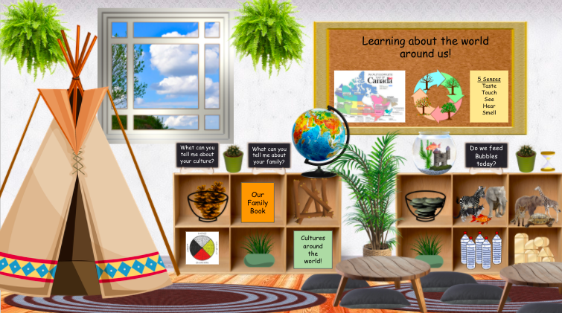

______________________________________________________________________________
Cozy Corner:
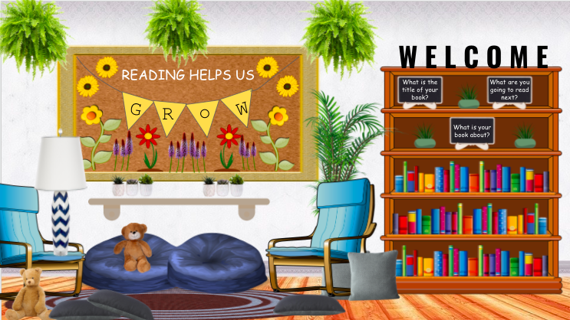
The Cozy Corner is a place where students can sit and enjoy an array of books. In this area the atmosphere is very relaxing and cozy. The plants in this area make it an enjoyable place to spend time. The main material in this area is books. In the classroom library there would be many different kinds of books for the interests of the students. To make it comfy there are many beanbags and pillows for students to sit on when they read. There are a few comfy chairs to sit in and read as well. The questions are prompts for the students to think about before, during, and after reading their books. the bulletin board in this area is inspirational for the students. This bulletin board could be changed to relate to the different learning theme in the classroom as well. I think it will be beneficial for students and they will enjoy reading in this area.

______________________________________________________________________________
Student’s Desk Area:
In the student desk area, the work surfaces will be arranged in pod groups of 4 students. The desks will make this area feel hard because there are no softening aspects (Massing, 2021c). The main materials in this area will be the desks. In the desk pods, as the teacher I would assign the students to a specific spot. Assigning desks encourages students to mingle with other students and not just their best friends. It is very important for students to interact with each other during their school experience (Massing, 2021b). I would add a small plant in the middle of the student’s desks to soften up the hard space. At their desk’s students will do their writing or other activities asked by the teacher. Students will also eat their lunches and snack in these groups. This would be like your tradition classroom area.
______________________________________________________________________________
Art Area:
In this area the students are encouraged to create whatever they desire. They are welcome to use their creativity and create their own masterpiece. In my dream classroom, I will display the student’s artwork, so they can enjoy their own and peer’s art that has been created. Displaying student’s artwork in the classroom will also make the classroom feel homey (Massing, 2021b). This area has the most vibrant colors because the student’s artworks are quite colorful. I have separated this area from the others because the color tone is not similar to the rest of the room. The materials in this area are also very vibrant because of the supplies provide for students to create their art projects. Some materials in this area are markers, pencil crayons, paper, cardboard squares, glue, scissors, and shapes. There could be many other materials added to this area. A classroom theme could be incorporated into this area by adding related materials. For example, in winter snowflakes could be added as an item to glued on to the student’s artwork. There are many materials provided to the students. In this learning area, there are cardboard squares for students to create art in any way they desire. There could be any other recycled materials used for this art area such as buttons, fabric, or baskets (Massing, 2021d). The prompt questions could also be changed to relate to the classroom theme. This area may get a little messy and disorganized while students are creating, but after there is a place for everything to go back on the selves. I think this is a fun creative area that students will enjoy!
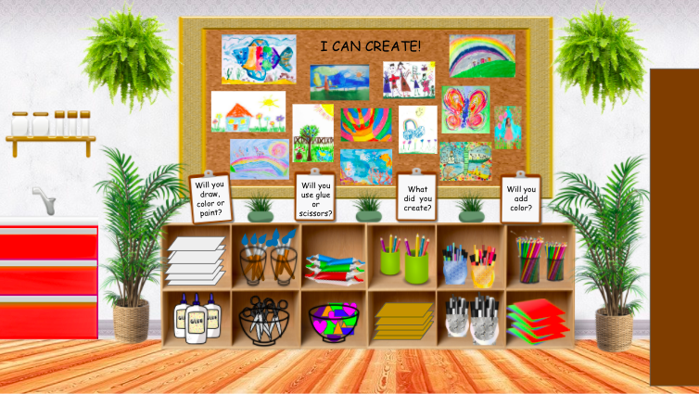
Children’s art- https://www.google.com/search?q=childrens+art&sxsrf=ALeKk00eO4qPBz0HwsKBpvgFGp9XpDkiiQ:1617046775469&tbm=isch&source=iu&ictx=1&fir=PtNv1Mnms_4qHM%252CKooPnJn5XdngNM%252C_&vet=1&usg=AI4_-kRUS2oH9WEQOc8IySvKr-2eafWOVQ&sa=X&ved=2ahUKEwiD24vVoNbvAhVKmlkKHXp8Bt4Q9QF6BAgMEAE&biw=1097&bih=690
______________________________________________________________________________
Diversity in the Classroom:
In my classroom everyone will be accepted and welcomed. As teachers we need to create a place where students feel they belong (San Francisco Public Library, 2018). It is so important for student to feel accepted in a classroom, so they enjoy coming to school. Children should explore their skin color every day, not just one day a month (San Francisco Public Library, 2018). In this classroom, I have a book about the students’ families. This allows students to recognize the differences and similarity of the families of their peers. I think it is important to talk about the different family dynamics of the students so the class knows everyone is different and that’s unique. I also will in cooperate the student’s cultures and traditions into the classroom. it is important to do some research on other cultures to learn about it (San Francisco Public Library, 2018). I have a book about cultures around the world on the shelf for students to look at. I also think it would be great to get the families of the students in to explain their culture and tradition to the class (San Francisco Public Library, 2018). I will become interested and will ask my students about their culture when I have questions. I think this is a great way to incorporate cultural diversity. I will also celebrate other traditional holidays in my classroom other than my own holidays because holidays are important in all cultures but they are all different (San Francisco Public Library, 2018). In this classroom, I have incorporated aspects of First Nations culture such as the medicine wheel and the teepee. First Nations people were the first people on this land we call Canada and we are all treaty people in Canada. I hope to have an elder come to my classroom and talk about the First Nations culture. It is a good idea to learn from people who know their culture first hand (San Francisco Public Library, 2018). On the student’s lockers they make their own name tags to express their own personality and uniqueness. I think it is important for students to have choice in what they want to express. I want the students in the classroom to understand everyone is unique in their own way and we don’t have to be like other people. I have many inspirational quotes around the room to make students realize they can do anything they put their mind too and its okay to be different. Not all student’s ability levels are the same and I want them to know that is okay to if they are unable to do something a peer can do. In my classroom, I do not want girl things and boy things, I just want resources that everyone can use and learn with (Derman-Sparks, Olsen Edwards, & Goins, 2020). I do not want the student to be made fun of if they are playing with a doll or reading a gender specific book. I want all my students to be kind to one another and accept everyone for who they are. As a teacher, I think it is important to have discussions with the class to talk about differences and similarities of people. It will be very educational and useful for the students to understand and be comfortable talking about and interacting with people who are different than themselves.
______________________________________________________________________________
Role of the Teacher:
In this classroom, the teacher will have multiple roles. The teacher will be the facilitator for some actives such as morning meets and to introduce units or lessons to the class. Whole group instruction never reaches all of the students (Davidson Films, 1996). The teacher will also step back and let the students facilitate in these types of experiential learning areas (Massing, 2021f). Hands on learning is a great way for students to get involved in their learning. Children need to be actively involved in activity to gain the experience; they will not take away the same amount is they just observe (Davidson Films, 1996). In this case the teacher would have to gather and set up the materials and space for the students interact with and learn. It is important for the teacher to travel around the classroom while the children are interacting with the student facilitated activities to make sure they are on the right track (Davidson Films, 1996). When students are learning in the exponential learning area, as a teacher you could use the private speech approach to help the child solve the problem by talking through the task with the student (Massing, 2021f). A way to encourage students is the ask questions about what they are doing with the materials to understand their learning. In a classroom, it is important for scaffolding to be used. Scaffolding has many components in order for it to achieve goals above what they already know (Davidson Films, 1996). Scaffolding is when a teacher adds or takes away components of learning to advance or make the task manageable for students, there are many steps taken in the process of completion (Massing, 2021f). It is when a teacher assesses a student, and looks past their current skill to get them to the next step (Davidson Films, 1996). Teachers should guide the students in a way which will encourage them to gain understanding of what they are learning (Davidson Films, 1996). The assisted performance leads to individual performance in the future (Davidson Films, 1996). As a teacher, I think it is important to communicate with the students’ parents regularly. Sending home questionnaires could be a way to ask questions to parents about the child’s home life and culture such as holidays celebrated or family connections to learn more about your students (Massing, 2021g). Notes or emails are a great way to let parents know what is happening in the classroom and what their child is learning. I think it is important to communicate with parents when their child has accomplished an important milestone and not just when their child has done something wrong. Parents enjoy hearing the positive things their child is doing. Allowing parents to come into the classroom to see their child’s surrounding and meet the teacher allows parents to feel comfortable with their child attending (Massing, 2021g). When parents feel a connection with the teacher and class they are more likely to volunteer in the classroom, go on field trips, or donate for supplies to the classroom (Massing, 2021g). A teacher should have positive relationships with the students. I will encourage all my students to do their best in and outside of the classroom. It is important to work together with your students and enjoy the relationships (Malaguzzi, 1994). I want to be a teacher that all students feel comfortable talking to about anything. I also want students to respect my rules and myself as a teacher. I will have rules in my classroom so the classroom atmosphere is controllable and comfortable for everyone in it. I hope students enjoy being in my classroom and learning with me.

Resources:
Davidson Films. (1996). Scaffolding Self-Regulated Learning in Primary Classrooms. [video]. Films on Demand. https://fod-infobase-com.libproxy.uregina.ca/p_ViewVideo.aspx?xtid=44922
Derman-Sparks, L., Olsen Edwards, J., & Goins, C.M. (2020). Anti-Bias Education for Young Children and Ourselves (second edition). Washington, DC: National Association for the Education of Young Children.
Malaguzzi, L. (1994). Your image of the child: Where teaching begins. Exchange, 3, 1-5.
Massing, C. (2021a). Curriculum and Experiential Learning Part 3: Overview. Regina: University of Regina.
Massing, C. (2021b). Environments for Experiential Learning: Overview. Regina: University of Regina.
Massing, C. (2021c). Environments Video. [Video]. Regina: University of Regina. https://www.dropbox.com/s/qo28qgi4wz35c1a/Environments%20Video.mp4?dl=0
Massing, C. (2021d). Materials of Experiential Learning: Overview. Regina: University of Regina.
Massing, C. (2021e). Planning for Experiential Learning: Overview. Regina: University of Regina.
Massing, C. (2021f). Teacher Role in Experiential Learning: Overview. Regina: University of Regina.
Massing, C. (2021g). Teacher Role in Experiential Learning (Part 2): Overview. Regina: University of Regina.
San Francisco Public Library. (2018, April 19). Miriam Beloglovsky “Play Equity” at the San Francisco Public Library. [Video]. YouTube. https://www.youtube.com/watch?v=IovZyfq77AQ
Tarr, P. (2001). Aesthetic Codes in Early Childhood Classrooms: What Art Educators Can Learn from Reggio Emilia. Art Education, 54(3), 33–39. http://doi.org/10.2307/3193922

