**Setting**

Name____________________

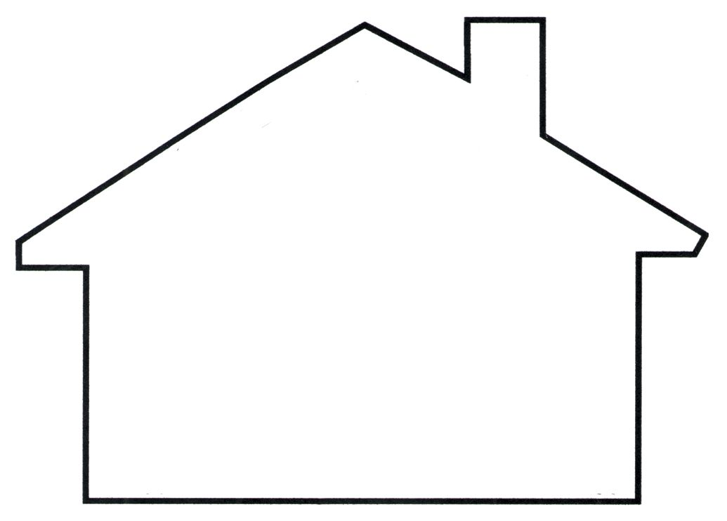

_______________________________________________________________________________________________________________________.

_______________________________________________________________________________________________________________________.

_______________________________________________________________________________________________________________________.

Word Bank

Straw Sticks

Bricks