**Setting**

Name____________________

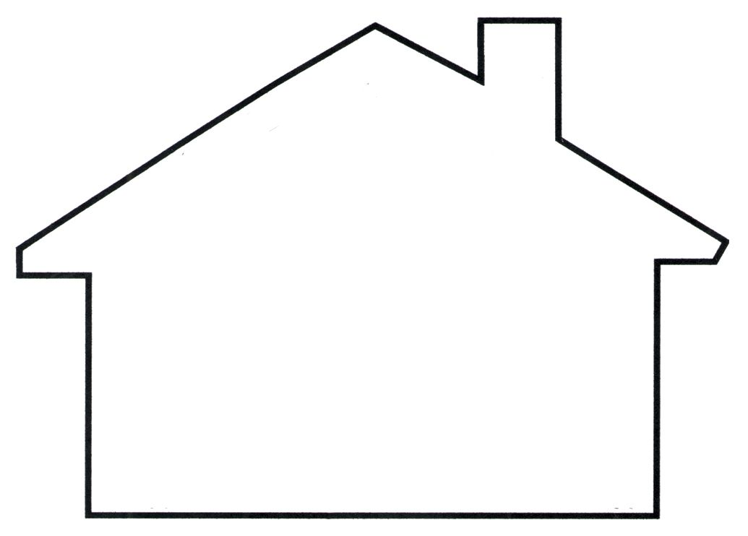

Word Bank

Straw Sticks

Bricks

The third pigs house was made of ____________.

The second pigs house was made of ____________.

The first pigs house was made of ____________.